

**EAST WEST UNIVERSITY**

**Course Title:** Computer Networks

**Course Code:** CSE405

**Section No:** 2

**Project Report**

**Project Title:** Design a full-fledged network for an organization with multiple subnets

**Submitted To:**

Dr. Anisur Rahman

Assistant Professor,

Department of Computer Science and Engineering,

East West University.

**Submitted By:**

Shaykh Siddique

ID: 2016-1-60-053

**Title:** Design a full-fledged network for an organization with multiple subnets.

**Objective:**

INTERNATIONAL APEX UNIVERSITY have a large number of computers with complex network infrastructure. Internet connection with classrooms, labs, employee and faculty PC. The university also have a website, mail server, DNS server.

**Tools:** Cisco Packet Tracer is used to design this network.

**Design:**

We can divide the main part of design into four parts. All this four parts are connected with routers. We used 2811 router and from each router we created internal LAN system by using 2950T-24 switch.

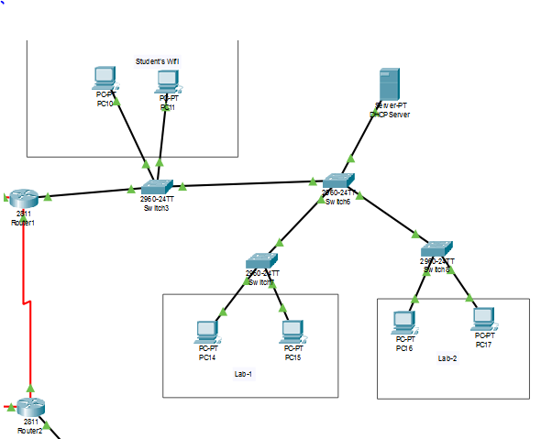

Here, we used a DHCP server which will provide the ip addresses automatically to devices. The tree parts used as two for students’ lab and one for students’ wifi.

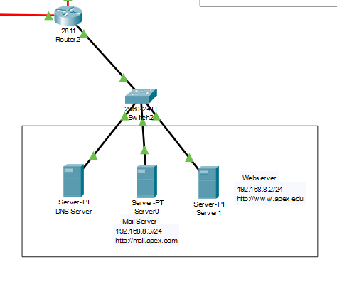

The webserver and mail server is for university website and SMTP mail server. DNS server is controlling the DNS.

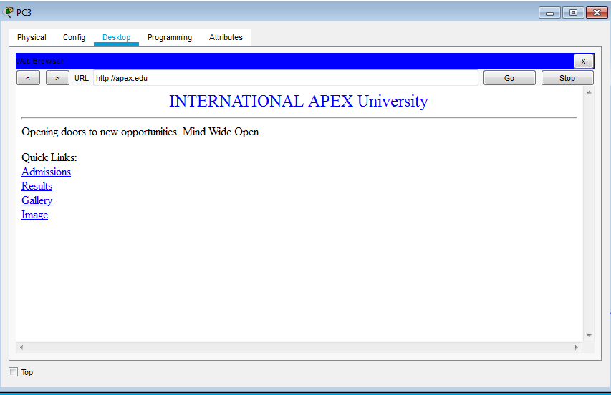

University website URL is <http://apex.ewu> and mail server URL is <http://mail.apex.ewu> .

The overall network looks like –

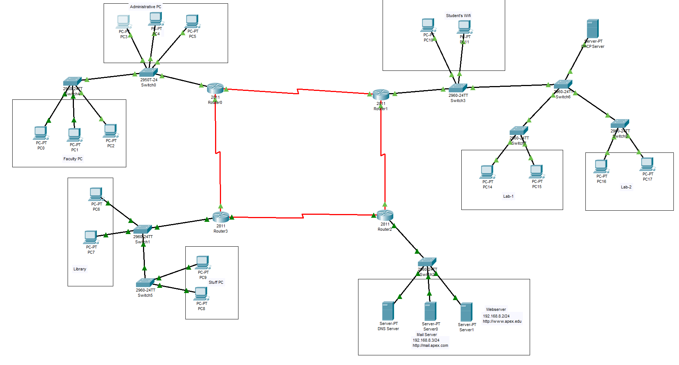

**Conclusion and Future Improvements:**

For faculty and administrative pc we used static ip. So for automatic ip allocation future we can use a DHCP server. Also in the library network for more computer we can use another switch. Overall as this university network system is complex, we are solving those problems and keep the network simple.